**SPRINT – 4**

**PROJECT - Signs With Smart Connectivity For Better Road Safety**

**TEAM ID - PNT2022TMID21659**

**IOT PLATFORM**

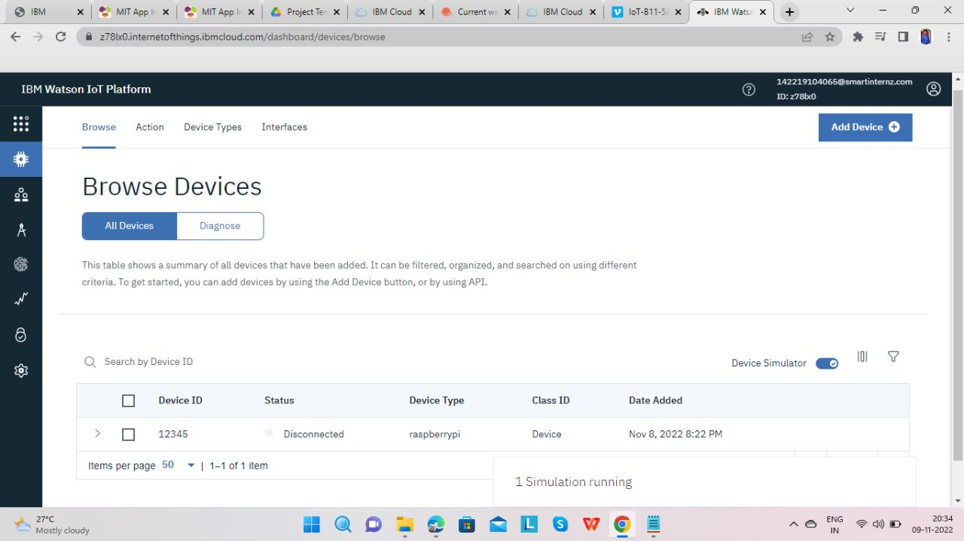

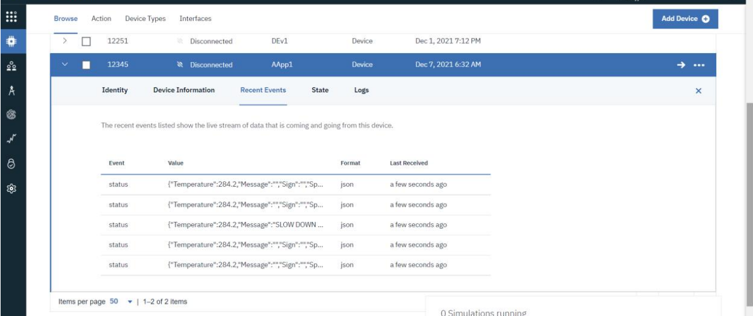

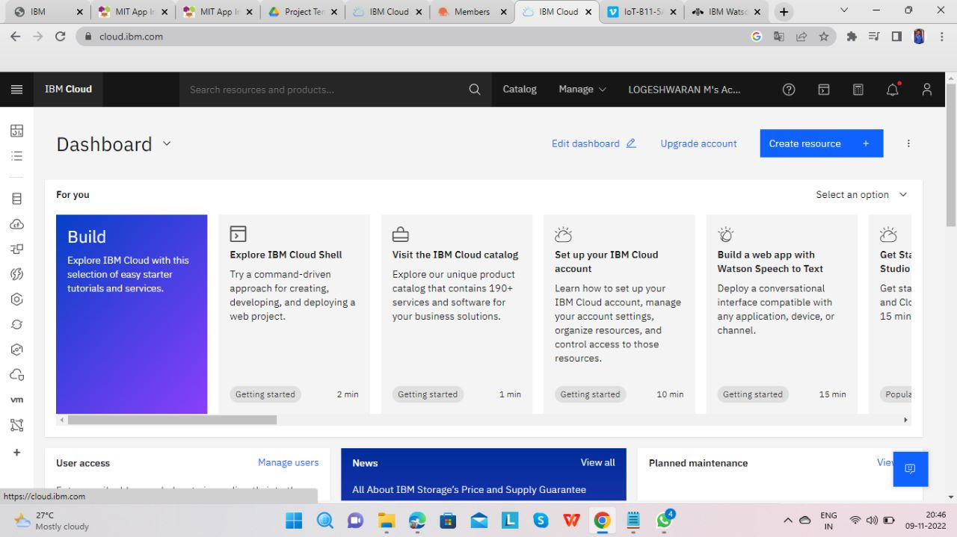

**OPEN WEATHER APP API KEY**

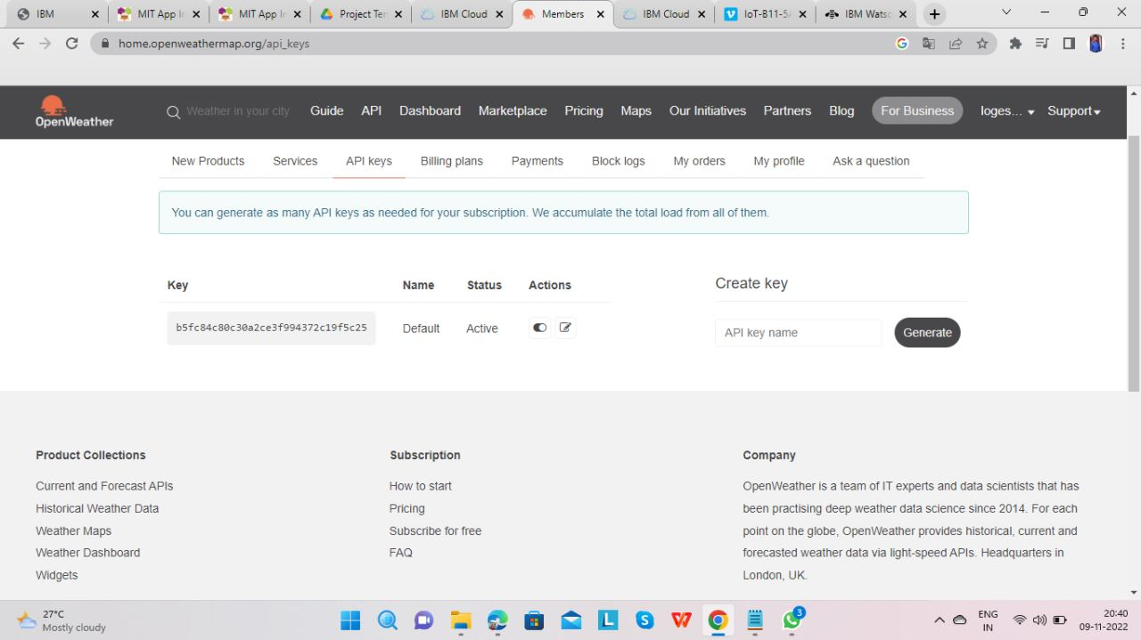

**APP UI SAMPLE**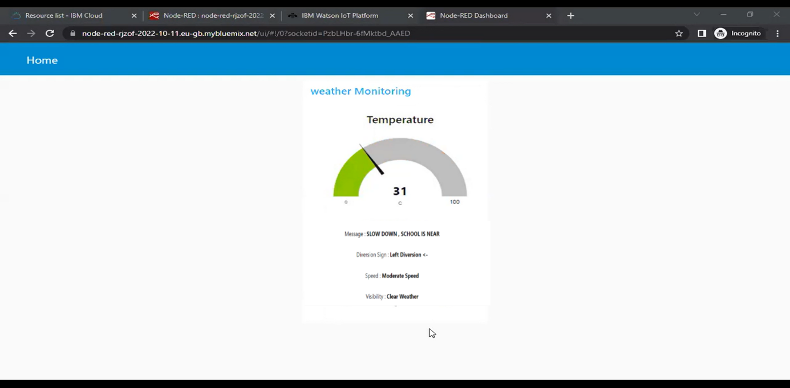

**NODE RED**

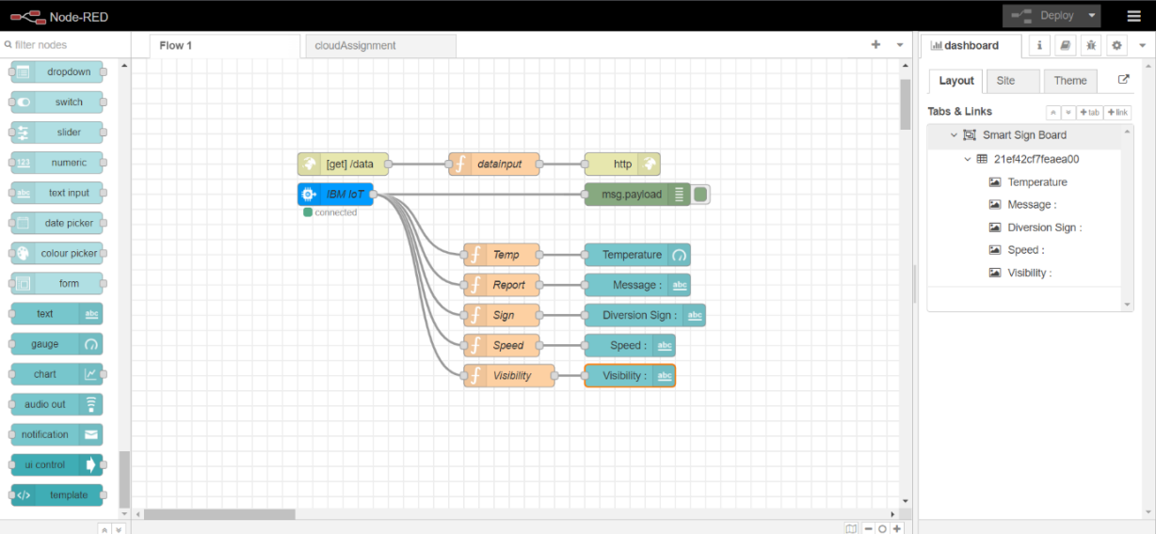

**PYTHON OUTPUT**

